

DECO7180: Design Computing Studio – Interactive Technology

Problem Framing Report
for
Events and public toilet locations
in Brisbane City

Team Name: NAAH
Team Members
Student Name | Student ID
Hayden
Anjali
Apurva Tripathi
Niwel Abel | 49422311

Table of Contents
1. Introduction 3
2. Discussion of Data 4
2.1 Dataset 1 – Brisbane Events Data 4
2.2 Dataset 2 – Public Toilet Locations 4
2.3 Bias / Interpretation Risks 4
3. Defining the Problem Space 5
4. Identifying Gaps of Knowledge 6
4.1 Research Question 6
4.2 Prototype Idea 6
5. Conclusion 7
6. References 8
7. Acknowledgment of Generative AI usage 8

Brainstorming [DELETE WHEN DRAFT IS COMPLETE
Key Concept: Data → Insights → Problem Space → Research Questions
Focus areas:
- Analyse at least two datasets
- Identify patterns, issues, or relationships
- Define a problem space
- Develop a design question
- Identify knowledge gaps and future research

Introduction

Discussion of Data

Dataset 1 – Brisbane Events Data

Dataset 2 – Public Toilet Locations

Bias / Interpretation Risks

Defining the Problem Space

Identifying Gaps of Knowledge

Research Question
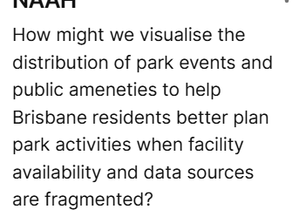

Prototype Idea

Conclusion

References

Acknowledgment of Generative AI usage

